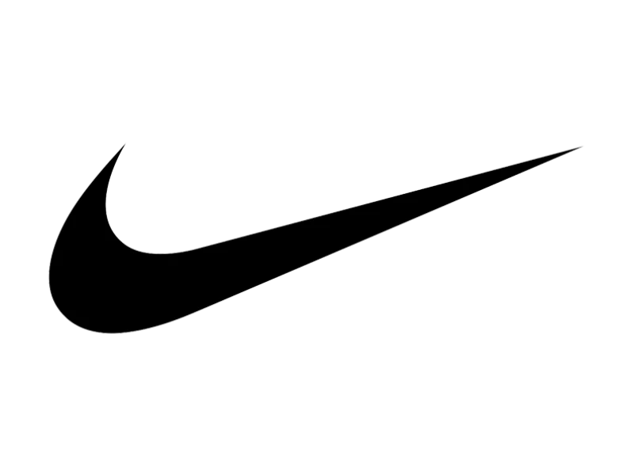
WINNING THE
NEXT GENERATION
Market Research & Analysis | India
Independent Hypothetical Consulting Case Study

Prepared by | Scope | Status
Tushar Verma | Indian sportswear market, consumers aged 18 - 27 | Research foundation, hypotheses require validation

Important: This is an independent portfolio case study. It is not commissioned by, affiliated with, or endorsed by Nike. Public market estimates vary by category definition and research provider. Consumer segments and strategic opportunities are hypotheses unless explicitly supported by cited evidence.

1. Executive Summary
This report assesses the market context for a hypothetical strategy to strengthen Nike’s relevance among consumers aged 18 - 27 in India. It reviews the sportswear and athletic-footwear opportunity, category trends, consumer questions to validate, the competitive landscape and implications for a potential go-to-market strategy.
Euromonitor’s public India sportswear summary reports 2025 retail sales growth of 11% to INR 824.1 billion and forecasts a 10% CAGR to INR 1.30 trillion by 2030 [1]. Separately, an athletic-footwear estimate cited in a listed company’s annual report values the Indian category at USD 5.9 billion in CY2024 and forecasts a 5.2% CAGR to approximately USD 9.8 billion by CY2033 [2]. These are distinct category lenses and should not be added together.
The evidence points to research priorities around performance versus everyday use, affordability and value, online discovery versus physical trial, and competition from global, specialist and domestic brands. The available public summaries do not establish Nike’s Gen Z consideration, conversion or market share specifically.

Key takeaways
- Published research describes a substantial Indian sportswear category with further growth forecast, although exact size depends on product and channel definitions [1].
- Comfort, versatility, fitness awareness, athleisure and omnichannel retail are identified as relevant category themes [1].
- Euromonitor’s public summary lists Puma (6%), adidas (5%) and Skechers (4%) company shares in its India sportswear competitive landscape, these are not Gen Z preference shares [1].
- Personas in this report are working hypotheses, not measured or validated segments.
- Primary research should validate purchase drivers, willingness to pay, consideration, channel preferences and conversion barriers before finalizing strategy or financial estimates.

2. Business Question, Objectives & Scope
Core question: How could Nike strengthen its relevance among Indian Gen Z consumers and convert that relevance into sustainable, profitable growth?
Element | Definition
Business challenge | Explore how Nike could increase consideration and conversion among consumers aged 18 - 27 without assuming uniform needs or spending power.
Geography | India, pilot clusters to be selected after evidence review.
Target audience | Consumers aged 18 - 27, including students, early-career professionals, fitness participants and sneaker enthusiasts.
Category | Sportswear broadly, with separate attention to athletic footwear and sports apparel where source definitions permit.
Out of scope | Nike internal sales, customer data, confidential strategy, actual campaign performance and unsupported market-share estimates.
Decision output | Evidence-led consumer and competitor insights to inform a testable growth strategy and later financial business case.

3. Methodology & Evidence Standards
This secondary-research-led assessment uses publicly accessible summaries of market research and a company annual-report extract. Full proprietary datasets and underlying methodologies are not available from free summaries. Published figures are therefore treated as directional estimates, not independently audited facts.
- Use each source’s own category label, geography, base year and forecast period.
- Do not combine sportswear, sports apparel and athletic-footwear estimates unless overlap and definitions are reconciled.
- Separate observed evidence from interpretation, assumptions and hypotheses.
- Do not infer Gen Z-specific behaviour from all-age market data.
- Validate high-impact hypotheses with primary research before treating them as findings.

4. Indian Market Overview

4.1 Market size: category boundaries matter
Market lens | Published estimate | Interpretation / limitation
Sportswear in India | INR 824.1 billion in 2025, 11% current-value growth, forecast INR 1.30 trillion by 2030 at 10% CAGR [1]. | Broad sportswear retail lens. Not equivalent to footwear-only or apparel-only market.
Athletic footwear in India | USD 5.9 billion in CY2024, forecast 5.2% CAGR to about USD 9.8 billion by CY2033 [2]. | Footwear-specific estimate cited in a listed company annual report, sourced there to IMARC.
Sports apparel in India | Ken Research public summary estimates USD 812 million in 2025 and 14.52% CAGR to 2031 [3]. | Apparel-only estimate, definition differs. Use cautiously and verify full methodology.

The difference between estimates is itself a research consideration: providers may include or exclude apparel, footwear, accessories, channels and price segments. For this case, use Euromonitor’s sportswear estimate as a broad reference and the athletic-footwear estimate as a separate lens. Do not blend them into one total.

4.2 Growth context
Euromonitor identifies rising disposable incomes, an expanding urban middle class, demand for comfortable and versatile clothing, fitness awareness and athleisure adoption as drivers or themes in India’s sportswear category. It also highlights omnichannel retail, digital engagement, inclusive design and evolving preferences [1]. These are category-level observations, their importance to Nike’s 18 - 27 audience must be validated.

4.3 Addressable market versus total market
A national market value is not the same as Nike’s addressable opportunity. A later model should narrow the category by relevant products, age cohort, geography, purchase participation, price accessibility and the realistic reach of a pilot.
Addressable annual spend = target consumers × annual category participation rate × relevant annual spend per participating consumer
Serviceable pilot opportunity = addressable spend within selected cities, channels and product categories. Each input must be sourced or explicitly labelled as an assumption. This report does not claim a validated TAM, SAM or SOM.

5. Consumer Research: Gen Z in India
The sources reviewed provide category context but do not provide representative measurement of Nike consideration, willingness to pay or conversion specifically among Indian consumers aged 18 - 27. This section therefore defines a research framework rather than presenting unverified consumer findings.

5.1 Working segments
Working segment | Potential need-state | Questions to validate
Campus trendsetters | Style, identity, peer discovery, versatile everyday products | What drives brand choice? What is affordable? Which occasions and channels matter?
Fitness enthusiasts | Comfort, fit, durability, performance and progress | Which activities matter? What benefits justify a premium?
Young professionals | Versatility, comfort, quality and convenience | How do purchase occasions and budgets differ from students?
Sneaker & culture enthusiasts | Design, brand story, community, launches and access | How important are limited releases, authenticity and availability?

These segments are not mutually exclusive or statistically validated. They are practical lenses for interviews and survey analysis one respondent may fit multiple segments.

5.2 Hypotheses to test
- Affordability and perceived value may constrain consideration or purchase for some young consumers.
- Style and versatility may matter when sportswear is used for both activity and everyday wear.
- Creators, peers and sport communities may influence discovery, influence on actual purchase should be measured separately.
- Availability, fit guidance, authenticity assurance and ease of purchase may affect conversion.
- Needs and willingness to pay may vary by city, income, gender, activity and channel.

5.3 Proposed primary research
Method | Suggested design | Output
Online survey | Exploratory sample of 100 - 150 Indian respondents aged 18 - 27, capture location, status, activity, spend, awareness, consideration, drivers and barriers. | Directional patterns only, not nationally representative.
Short interviews | 8 - 12 interviews across student, professional, fitness and sneaker-interest profiles. | Consumer language, decision journey, unmet needs and context.
Digital shelf audit | Review official brand sites and selected authorized platforms for price, product information, size / stock visibility and storytelling. | Comparable customer-facing discovery audit with date and sampled SKUs.
Store observation | Observe a small set of stores for product mix, merchandising, trial and assistance, if feasible. | Qualitative channel observations, not total retail performance.

Suggested questions: What was your last sportswear or athletic-footwear purchase? Which brands did you consider? What did you buy and at what price? What were the top reasons? What stopped you from buying another brand? Where did you discover and purchase it? Would a specific functional benefit, design or brand association justify a higher price?

6. Competitive Landscape
The competitive environment includes international sportswear brands, sports specialists, domestic footwear players and lifestyle / athleisure labels. Competitors overlap differently by product, price, use occasion and channel, one overall ranking would obscure these differences.
Brand / group | Broad positioning lens | Research implications
Nike | Global sports-performance heritage and sport / lifestyle franchises. | Assess local relevance, product access, value perception and connection between sport credibility and everyday use.
adidas | Sports heritage and established lifestyle franchises, 5% company share in Euromonitor’s summary [1]. | Compare lifestyle cues, assortment, channel access and segment perceptions.
Puma | Performance and sportstyle presence, 6% company share in Euromonitor’s summary [1]. | Understand perceived price, style, performance and accessibility relative to Nike.
Skechers | Footwear-led comfort and lifestyle relevance, 4% company share in Euromonitor’s summary [1]. | Test comfort, fit, value and everyday walking use cases.
Decathlon | Sports-specialist retail and broad activity-specific assortment. | Compare activity coverage, price, product education and physical trial.
Domestic / digital-first brands | Includes Campus Activewear and BlissClub, positioning varies by product and segment. | Examine affordability, local relevance, fit, availability and community engagement.

The 6%, 5% and 4% shares are company-level shares in Euromonitor’s public summary—not a complete market-share table, brand awareness scores or Gen Z-specific preference data [1]. A competitor audit should record date, category, product type, price and source.

6.1 Competitor comparison framework
Dimension | Evidence to collect | Why it matters
Product & use case | Performance claims, materials, fit, assortment by activity / lifestyle | Relevance to target occasion
Price & value | Comparable SKU prices, discounts, entry price and product benefits | Affordability and perceived value
Brand & culture | Campaign themes, athlete / creator partnerships, community activity | Discovery, identity and engagement
Channel access | Official stores, retail partners, size / stock visibility | Ease of finding and buying
Experience | Product education, reviews, returns, trial and service | Trust and purchase confidence

7. Category Trends & Strategic Implications
Category theme | Evidence | Potential implication to test
Comfort & versatility | Euromonitor identifies demand for comfort and versatile sportswear [1]. | Test everyday-use storytelling and products spanning activity and casual occasions.
Fitness & athleisure | Euromonitor identifies fitness awareness and athleisure as category themes [1]. | Explore activity-based communities and performance-led education.
Omnichannel engagement | Euromonitor highlights omnichannel retail and digital engagement [1]. | Assess how digital discovery, physical trial and online purchase interact.
Inclusive design | Euromonitor identifies inclusive design as a forward-looking theme [1]. | Research fit, sizing, comfort and representation across respondents.
Value competition | Euromonitor notes value-fashion competition in the category [1]. | Test clear product-value communication, do not assume discounting is the answer.

8. Preliminary Opportunity Areas
These areas are supported as topics worth investigating, not proven drivers of incremental Nike sales.
Occasion-led relevance: Connect sport credibility to training, everyday wear, campus life and sneaker culture, validate which occasions have demand and brand fit.
Community and participation: Explore running, fitness, campus or local sport communities. Measure participation and subsequent behaviour rather than assuming direct sales impact.
Value clarity: Explain functional benefits, quality and use-case fit. Test whether clearer product education changes consideration or conversion.
Discovery and access: Review size availability, product information, channel consistency and the relationship between digital browsing and physical trial.
Focused pilots: Test a small number of segment / city / channel combinations with baseline or comparison measurement before broader investment.

9. Research Gaps & Validation Plan
Gap | Why it matters | Next action
Gen Z participation and spend | Broad market totals do not show age-specific spending. | Survey and identify reliable age-specific published datasets.
Nike consideration and conversion | Category growth does not establish Nike’s own funnel performance. | Measure awareness, consideration, recent purchase and barriers.
Willingness to pay | Feasibility depends on price acceptance and product mix. | Use price-band questions and comparable SKU audit.
Segment / city differences | A single message or offer may not fit all consumers. | Capture location, status, activity and spend, caveat small samples.
Incremental campaign impact | Attribution is needed for credible financial estimates. | Use baseline, matched comparison or holdout where feasible.
Consistent market sizing | Provider definitions differ by scope. | Select one definition and document inclusions / exclusions.

10. Preliminary Conclusion
Public market research describes India as a growing sportswear market shaped by comfort, versatility, fitness awareness, athleisure and evolving omnichannel behaviour [1]. The competitive context includes global brands and domestic / specialist alternatives. However, broad category growth alone does not prove an attractive Nike Gen Z opportunity.
The commercial question is which young consumers, product occasions, price-value propositions and routes to market can produce incremental demand at an acceptable cost. The proposed segments and opportunity areas should be tested through primary research and pilot measurement. Financial estimates should follow only after reach, conversion, average order value, gross margin and investment assumptions are explicitly documented.

11. Sources & References
[1] Euromonitor International, “Sportswear in India,” public country-report overview, accessed 30 September 2026. https://www.euromonitor.com/sportswear-in-india/report
Supports reported 2025 sportswear retail value / growth forecast, category themes and company share summary. The full proprietary report and methodology were not reviewed.
[2] Hindustan Foods Limited, Annual Report 2024 - 25, Management Discussion & Analysis, athletic-footwear estimate attributed in the report to IMARC. NSE-hosted report: https://nsearchives.nseindia.com/annual_reports/AR_27657_HNDFDS_2024_2025_A_11429527_25082025180640.pdf
Supports athletic-footwear estimate and forecast as cited in the annual report, original provider methodology was not independently reviewed.
[3] Ken Research, “India Sports Apparel Market Size, Share & Forecast, By Product Type, Customer Type & Distribution Channel, 2026 - 2032,” public market-page summary, accessed 30 September 2026. https://www.kenresearch.com/industry-reports/india-sports-apparel-market
Provides an apparel-only estimate, included to illustrate scope differences and treated cautiously.

Research limitations
Some referenced market-research reports are paid products, this report uses publicly accessible summaries and does not reproduce proprietary tables. Estimates may differ by category definitions, exchange rates, channel coverage and methodology. This report does not include original survey results, Nike internal data, audited Nike India segment economics or a validated TAM / SAM / SOM. Update it as primary research and additional source validation are completed.

